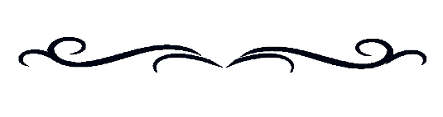
A PROCLAMATION

WHEREAS Indigenous peoples living with disabilities often face unique barriers that impact their ability to fully participate in the social and economic opportunities available in our communities. And

WHEREAS we are committed to the ideal of an inclusive society based on respect and understanding, where Indigenous peoples (First Nations, Métis, Inuit) living with disabilities and the significant contributions they provide to our communities, organizations, provinces., territories and country are recognized, celebrated, and valued. And

WHEREAS we are committed to upholding and safeguarding the principles outlined in the United Nations Convention on the Rights of Persons with Disabilities (CRPD), including full and effective participation and inclusion in society, equality of opportunity, and the United Nations CRPD International Committee’s recommendation to Canada to proclaim and recognize November each year as Indigenous Disability Awareness Month. And

WHEREAS we wish to recognize and support the British Columbia Aboriginal Network on Disability Society’s creation of Indigenous Disability Awareness Month (IDAM) and join governments, urban and rural Indigenous communities, disability organizations, individuals living with disabilities and their families, from across the country, in recognizing and celebrating these diverse and vital members of our communities.

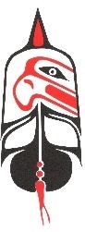
NOW, THEREFORE, be it resolved that we, Disability Alliance BC, do hereby proclaim and declare annually the month of November as:

Indigenous Disability Awareness Month

Dated this ___8th___ day of ___November___, 2021__

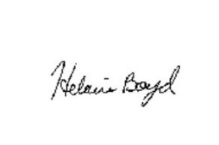
Helaine Boyd
Co-Executive Director of Disability Alliance BC_____________________ ________________
Name and Title Signature

