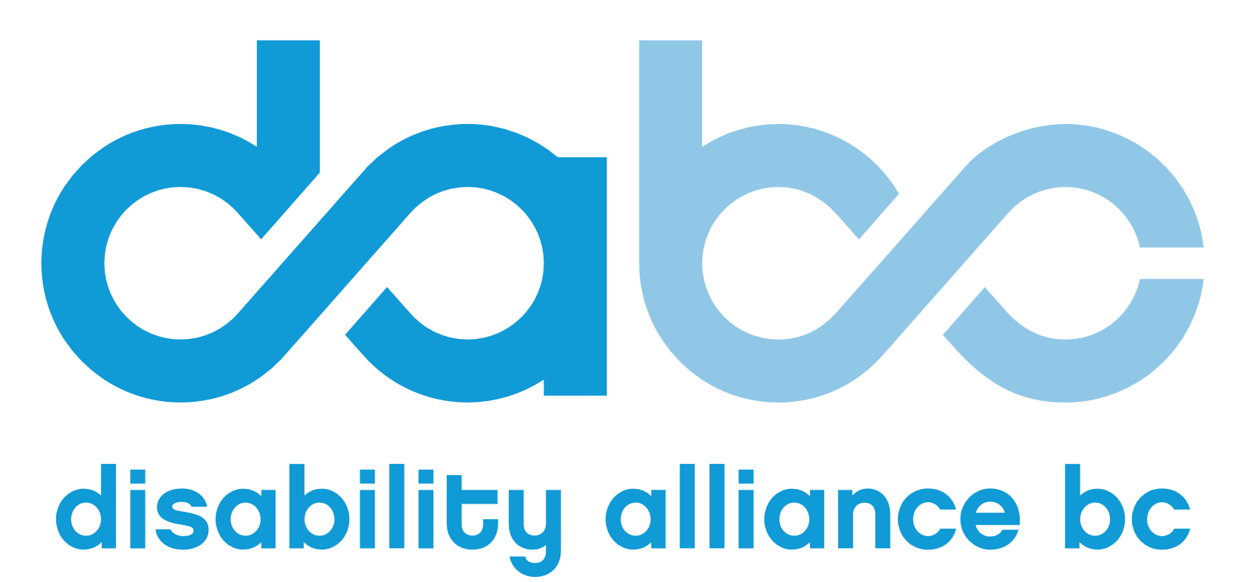
Council of Senior Citizens’
Organizations of B.C

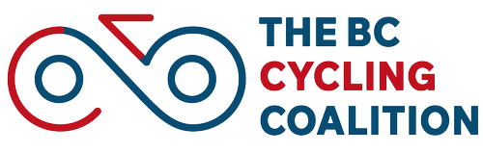

April 21, 2026
Dear Association of Vancouver Island and Coastal Communities (AVICC) Delegates:
Re: Please support AVICC resolution R19 Wheelchairs and Mobility Scooters in Bike-and-Roll Mobility Lanes and Routes
BC’s Motor Vehicle legislation presently inhibits the ability of seniors and people with disabilities to be active, independent, and engaged and creates a legal grey area regarding the use of wheelchairs and 3 & 4 wheel mobility scooters on bike lanes and routes.
We urge you to speak and vote in favor of the motion advanced by the City of Victoria that: “the UBCM advocate that provincial Motor Vehicle legislation and regulations be updated to allow the use of wheelchairs and 3&4 wheel mobility scooters on bike lanes and traffic calmed bike routes across BC.” This update would add choice for wheelchair and mobility scooter users, their right to use sidewalks and other pedestrian facilities would be maintained.
Electric drive technology has advanced in recent years, and many people in BC already use wheelchairs and (3 & 4 wheel) mobility scooters that can travel faster than is safe on even wide and well-maintained sidewalks. Mobility scooters and wheelchairs with top speeds of 15 km/hr to 25 km/hr (the legislated maximum) are now commonly available.
Some people with disabilities already use mobility scooters on the networks of bike and roll routes that municipalities have created. And BC’s human rights legislation requires that public infrastructure be accessible to people with disabilities. However, travel training programs need legislative certainty to be able to teach how to safely use this convenient, sustainable, and relatively affordable form of transportation.
Wheelchairs and 3 & 4 wheel mobility scooters have been used on bike and roll routes legally and safely for decades in other jurisdictions, including the state of Oregon. Quebec’s regulations allowing wheelchairs and mobility scooters on bike and roll routes and low-speed streets are already in place and can provide a potential model for BC to follow.
Please support this important advocacy motion. In addition, please consider proposing that your municipality and/or regional district write directly to Mike Farnworth, Minister of Transportation and Transit, advocating for this important change.
Council of Senior Citizens Organizations of BC (COSCO), Disability Alliance BC, HUB Cycling, and BC Cycling Coalition
coscobc.org disabilityalliancebc.org bikehub.ca bccycling.ca

