Disability Rights is More Than Just a Single-Issue Vote:

Key Election Priorities from
Disability Alliance BC

September 2024
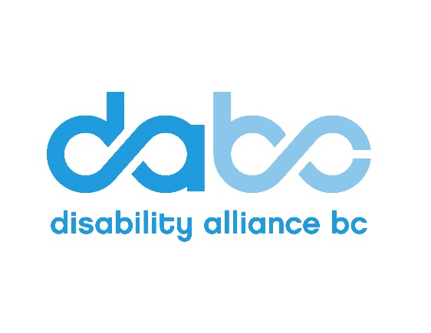

Introduction

During this BC Elections season, it is crucial to recognize the power of our collective voice within the disability community. With over 28% of British Columbians aged 15 years and older living with a disability, the perspective of the disability community within the political discourse should not be ignored. This document aims to highlight key election issues within the disability community and advocates for a provincial government that actively includes people with disabilities in shaping the future of our province.

Just as disability is not a monolith, disability rights is not merely a single-issue vote; rather, the inclusion of people with disabilities intersects a wide range of issues. We recognize that the issues Disability Alliance BC has highlighted within this document do not encompass all issues facing people with disabilities, and we therefore encourage every voter to advocate for the issues most important and personal to themselves as they cast their ballot on (or before) October 19, 2024.

Historically, the disability community has faced numerous barriers to participation in the electoral process, from inaccessible polling stations, to inaccessible all-candidates meetings, to inaccessible voter information. As such, this document also outlines voting accessibility—the various methods by which people can vote. We encourage any voters with disabilities to submit feedback to Elections BC if they experience any barriers to voting. The BC Poverty Reduction Coalition has also developed a handy voters guide which goes into broader detail about the elections process here.

It’s time to make disability rights an election priority, ensuring that the issues facing the disability community are not just acknowledged but actively championed within the political discourse of every election.

Accessibility in Voting

Voting in BC can be done by the following methods:

- You can vote in advance at designated polling stations.
- Vote by mail: you will need to request a mail in ballot by October 13, 2024. Learn more here.
- Assistive telephone voting is available if you are blind or “have a disability or health condition which makes it unsafe or otherwise prevents you from voting by other means”; other eligibility criteria is available to view here.
- Voter information should be available in accessible formats: large print, braille, ASL, and audio. This was outlined in Elections BC’s Accessibility Plan.
- Poll stations will be “physically accessible to voters using mobility devices. Voters who can’t enter a voting place can vote outside the building (at the curb or in the parking lot).” There are also Accessible Voting Systems at each district electoral office which will enable people with disabilities to vote independently. Ballots should be available in large print and braille.

Poll stations will include poll workers who can assist you with marking a ballot if requested. Voters are welcome to bring their own interpreter to the polling station to assist with language translation, signage or tracking. Friends or family members can help you vote as long as they declare they will do so according to your wishes. Voting independently is a key part of accessibility in the elections process and should not be sacrificed if there are other methods available by which to vote.
“if voting methods require or expect disabled electors to depend upon the aid of family or friend to cast their ballot, while offering little if any other options and accommodations which approximate the democratic paradigm of voting, then the disability status of that elector is likely to be personally experienced and publicly presented as an individual misfortune and problem of caregiving, a private responsibility, in large part; rather than be viewed as a social issue and problem of citizenship, a matter of human rights and public policy.”
All accessible voting options can be found on Elections BC’s website here and a link to Elections BC’s Accessibility Plan can be found here.

DABC advocates for increased accessibility in the voting process by ensuring:

- mail in ballots are also provided in accessible formats
- polling stations have quiet rooms
- all polling stations have designated accessible parking spaces
- people with disabilities have the option to vote in-person at their home through the implementation of elections outreach workers

If you find any part of the elections process inaccessible to you, please submit feedback to Elections BC here.

Election Priorities

We have categorized our election asks into 5 key priority areas. The below election priorities have been distributed to each political party. DABC will publish to our network any party responses we may receive.

In addition to the below election asks, as a member of the BC Poverty Reduction Coalition (BC PRC), Disability Alliance BC supports the election advocacy presented by the BC PRC in their factsheet, which can be found here.

Poverty Reduction

If elected, will your government commit to:

- Increasing the rate of provincial disability assistance to at least the poverty line and indexing to inflation.
- Actioning on changes to disability assistance as listed on page 34 of the 2024 Poverty Reduction Strategy, in particular
  - Abolishing earnings exemption limits; and
  - Removing clawbacks from employment insurance income and spousal income.
- Forming a single-purpose all-party committee to work with people with disabilities, families, Indigenous leaders, Indigenous communities, and key disability groups, to examine the current situation in BC and evaluate the implementation of a “disability insurance program” for people with disabilities with the following characteristics:
  - Entitlement to adequate funding for disability services and supports
  - Services to assist people in establishing and managing their own supports
  - The option to purchase supports through service providers and qualified professionals
  - Person-centred wrap-around services that enable community participation
  - Access to inclusive services such as childcare and education
  - Greater access to and better outcomes from services used by all British Columbians such as mental health, affordable housing and transportation.

Transit

If elected, will your government commit to:

- Eliminating fares for all public transit riders in BC who receive social assistance
- Streamlining the provincial bus pass program for people with disabilities to include HandyDART rides
- Enacting stricter laws that will ensure taxis and ride-hailing companies must provide accessible ride-hailing services.

Housing

If elected, will your government commit to:

- A dedicated rental subsidy program for low income people with disabilities
- Funding accessibility retrofits for existing social and rental housing
- Building more affordable, accessible housing that includes two, three, and four-bedroom units.

Healthcare

If elected, will your government commit to:

- Creating a dedicated, comprehensive medical equipment and assistive device program in BC
- Covering counselling and other mental health supports within BC’s medical services plan
- Improving home care and home support services to help ensure that people with disabilities have the supports they need to live in the community.

Accessible BC Act

If elected, will your government commit to:

- Funding organizations to support the implementation of their accessibility plans, and
- Funding to implement the accessible service delivery and accessible employment standards under the Accessible BC Act.

Statistics Canada. https://www150.statcan.gc.ca/n1/pub/11-627-m/11-627-m2023063-eng.htm
Elections BC Accessibility Plan. Page 13. https://elections.bc.ca/docs/accessibility-plan-2023.pdf
Enabling the Voter Participation of Canadians with Disabilities: Reforming Canada’s Electoral Systems - Michael J. Prince, Lansdowne Professor of Social Policy, University of Victoria. 2014. https://cjds.uwaterloo.ca/index.php/cjds/article/view/158/271
https://www2.gov.bc.ca/assets/gov/british-columbians-our-governments/initiatives-plans-strategies/poverty-reduction-strategy/2024-bc-poverty-reduction-strategy.pdf

