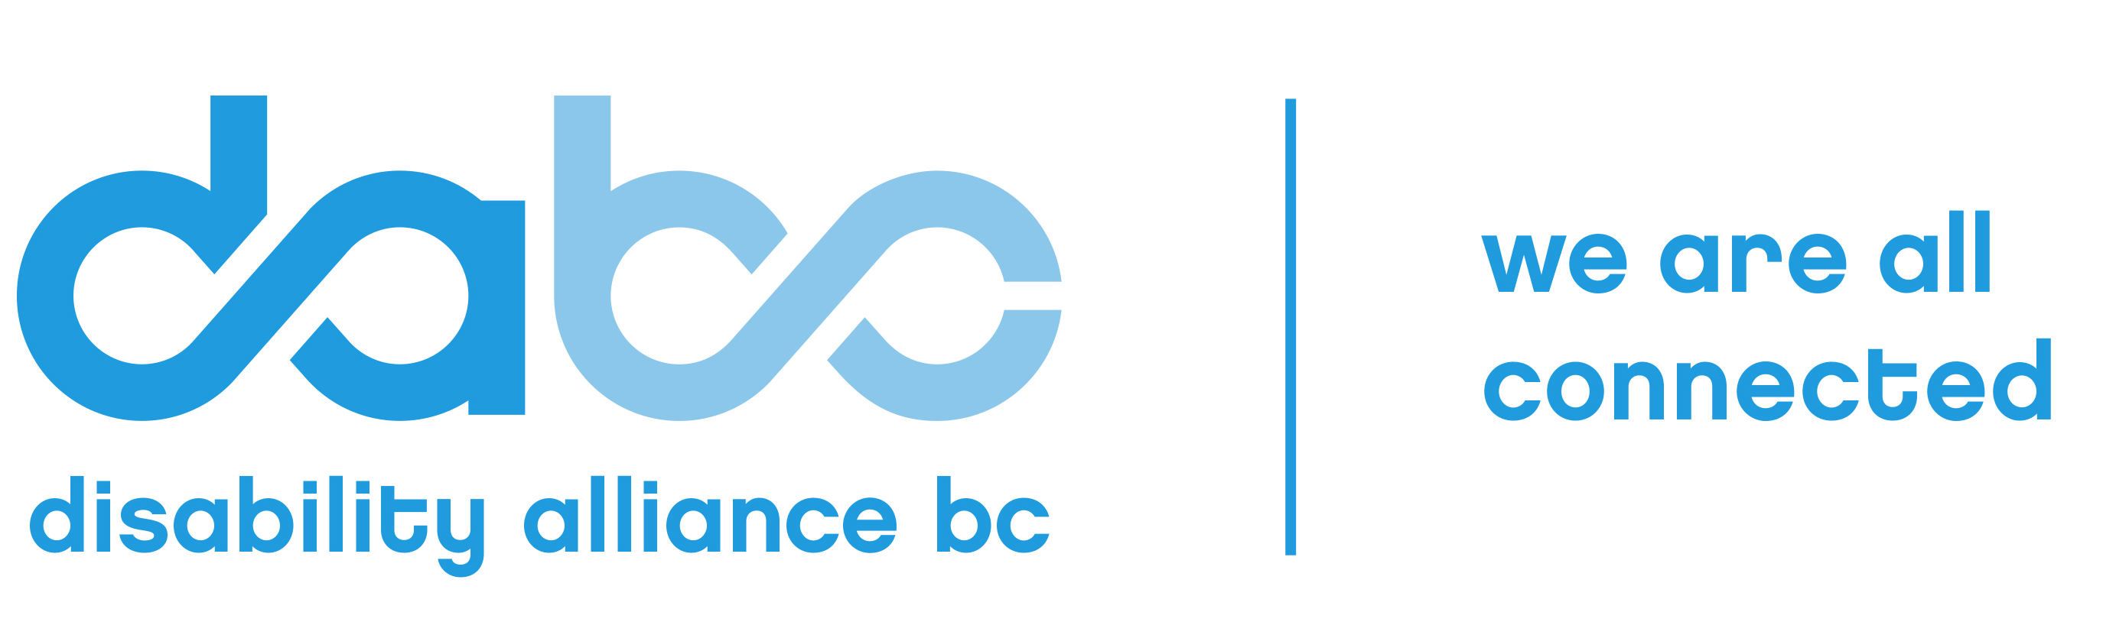
2017

Disability Alliance BC’s Outstanding
Employer/Employee of the Year
Awards

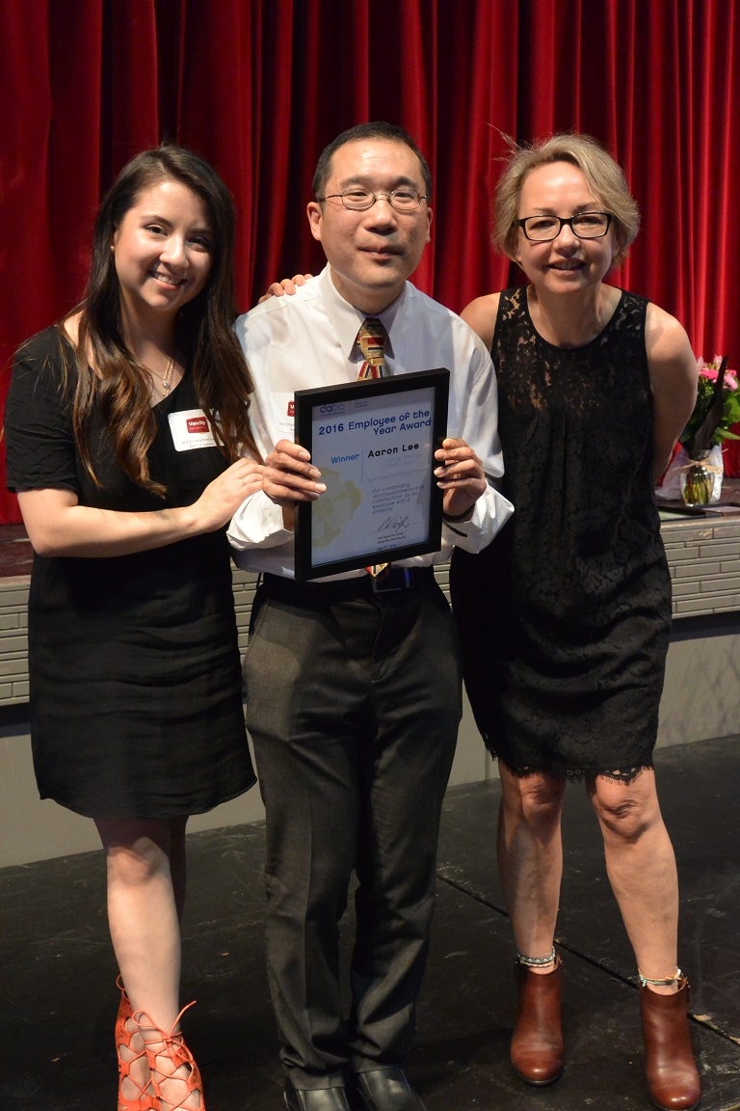
We’re delighted to announce that nominations are now open for Disability Alliance BC’s (DABC) 2017 Outstanding Employer/Employee of the Year Awards.

The unemployment rate for British Columbians with disabilities is significantly higher than that of non-disabled people.

This year, DABC will recognize a BC employer who has demonstrated excellence in the hiring and employing of people with disabilities. We will also recognize an outstanding employee with a disability who has exhibited exceptional skill or accomplishments in their work.
2016 Employee of the Year Award Winner: Jason Lee of Vancity

Outstanding Employer Award: Will be given to an employer nominated by one of their employees with a disability.
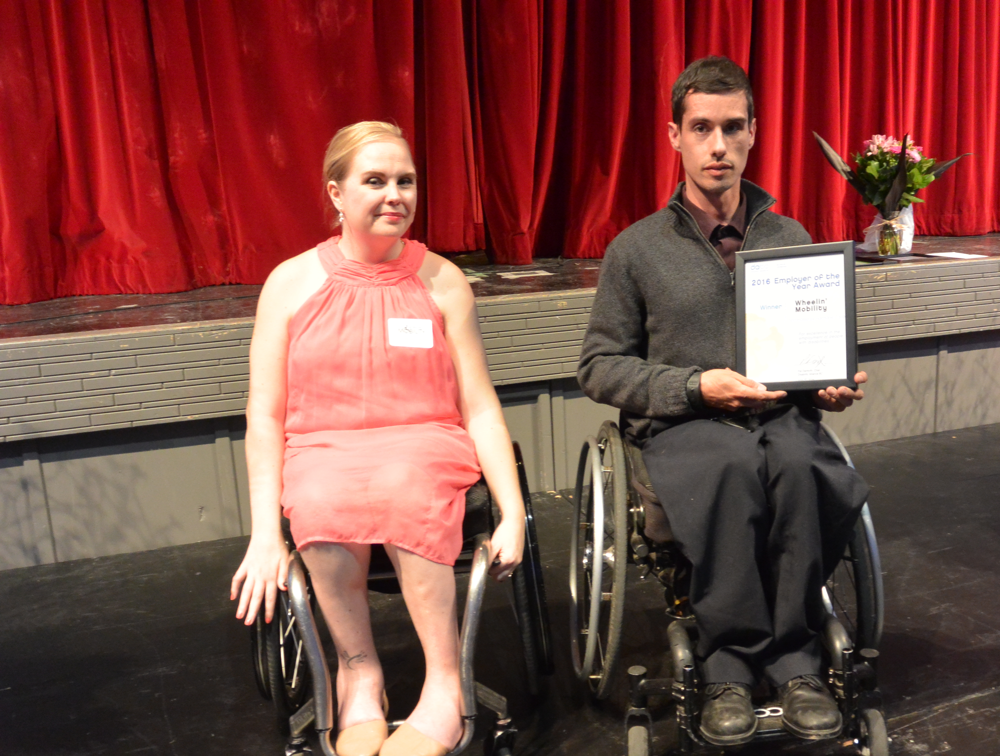
Outstanding Employee Award: Will be given to an employee nominated by an individual or organization who has demonstrated excellence in their field of work.

Award winners will be announced and presented with a plaque at DABC’s Fall Fling 40th Anniversary Fundraiser on October 4th 2017 at Vancouver’s Italian Cultural Centre
2016 Employer of the Year Award Winner: Wheelin’
Mobility
Tickets to Fall Fling 2017 are available on Eventbrite: https://fallfling-2017.eventbrite.ca or you can call 604-875-0188.

Deadline for Nominations: August 31, 2017

Completing your Nomination
Deadline for Nominations: August 31, 2017

Outstanding Employer Award
Nominators must have been a paid employee of the employer they are nominating at some point in the 18 months before the 2017 Award presentation.

Outstanding Employee Award
Nominators must have the endorsement of the employee with a disability they are nominating.

Nominated Employers
- Must be operating in BC at the time of the 2017 Award presentation.
- Agree to be nominated for the Award.
- Be willing to have their name made public at the Award presentation and in related announcements.

Nominators
Must be willing to have their name made public at the Award presentation and in related announcements.

Sending Your Nomination
Please send your nomination to:
Chloe Krause
Disability Alliance BC.

By Email:
chloe@disabilityalliancebc.org Please put DABC Outstanding Employer/Employee of the Year Awards in the subject line and send the nomination form as an attachment.

By Fax
604-875-9227

By Mail
Disability Alliance BC
#204 – 456 West Broadway
Vancouver, BC
V5Y 1R3

If you have any questions about your nomination, please call Executive Director Jane Dyson at 604-875-0188.

DABC 2017 Outstanding Employer Award
Nomination Form One

Complete Form One if you are a person with a disability nominating your employer.

Name of Nominator: ________________________________

Address: _________________________________________

City: ________________________ Postal Code __________

Phone: ___________________________________________

Email: ____________________________________________

I am willing to have my name made public at the Award presentation and in related announcements.

Signature: ____________________________

Date: _________________________________

Name of Nominated Employer: ___________________________

Contact Person: _______________________________________

Address: _____________________________________________

City: ________________________ Postal Code __________

Phone: _______________________________________________

Email: _______________________________________________

I have signing authority for my business/organization and I am willing to have my organization nominated for DABC’s 2017 Outstanding Employer of the Year Award. I am willing to have my name made public at the Award presentation and in related announcements. I understand that if my business/organization wins the Award it does not signify an endorsement of the services or goods we provide.

Signature: ____________________________

Name: _______________________________

Date: _________________________________

Questionnaire One

Questions 1 – 5 must be completed. Question 6 is optional.

Please keep your responses concise; for most questions we have suggested the maximum number of words for your answer.

1. How long have you worked or did you work for the employer you are nominating?

2. Please describe your disability and how it impacts your ability to work. (500 words maximum)

3. What kind of work are you doing/did you do for this employer? (500 words maximum)

4. Why are you nominating this employer? To answer this question:
i) List in point form up to 3 innovations/accommodations the employer has made.

ii) Tell us how these accommodations helped. (800 words maximum)

5. What suggestions do you have for businesses and organizations about hiring people with disabilities? (500 words maximum)

6. Do you have any other comments about employers/employment and people with disabilities? (500 words)

Thank you for taking the time to complete this nomination!

2017 Outstanding Employee Award
Nomination Form Two

Complete Form Two if you are nominating an employee with a disability.

Name of Nominator: ________________________________

Address: _________________________________________

City: ________________________ Postal Code __________

Phone: ___________________________________________

Email: ____________________________________________

I am willing to have my name made public at the Award presentation and in related announcements.

Signature: ____________________________

Date: _________________________________

Name of Employee with a disability: ________________________________

Address: _________________________________________

City: ________________________ Postal Code __________

Phone: ___________________________________________

Email: ____________________________________________

I am an employee with a disability. I support my nomination and am willing to have my name made public at the Award presentation and in related announcements.

Signature: ____________________________

Date: _________________________________

Nomination Form Two Continued

Name of Nominee’s Employer: ___________________________

Contact Person: _______________________________________

Address: _____________________________________________

City: ________________________ Postal Code __________

Phone: _______________________________________________

Email: _______________________________________________

I have signing authority for my business/organization and I am willing to have my organization’s name made public at the 2017 Outstanding Employee Award presentation and in related announcements. I understand that this does not signify an endorsement of the services or goods we provide.

Signature: ____________________________

Name: _______________________________

Date: _________________________________

Questionnaire

Questions 1-6 must be answered. Question 7 is optional.

Please keep your responses concise; for most questions we have suggested the maximum number of words for your answer.

1. Why are you nominating this employee? (500 words maximum)

2. What does the nominee do? What are their job responsibilities?

3. How long has the nominee worked for their employer?

4. What are the specific contributions and accomplishments that your nominee has brought to their work? (1,000 words maximum).

5. What is your personal connection to the nominated employee? (500 words maximum)

6. What suggestions do you have for businesses and organizations about hiring people with disabilities? (500 words maximum).

7. Do you have any other comments about employers/employment and people with disabilities? (500 words maximum).

Thank you for taking the time to complete this nomination!

