Have you had a legal problem that you needed solved? We want to hear from you!
UBC is sharing a 10-question survey that explores peoples’ experience finding and using free legal information, education, and resources to solve their legal problem (this includes the support of a legal advocate or free legal clinic). The survey will be open until February 28, 2025.

We want to hear from people who:
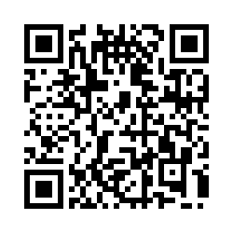
- Are over 18 years of age.
- Reside in British Columbia.
- Have had a legal problem and looked for free legal
information, education, and/or resources to solve
their legal issue (Note: the issue does not have to be resolved).

Scan the QR code to get started!

