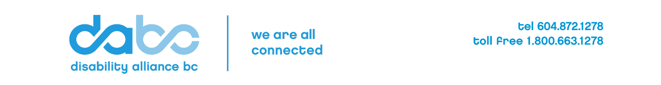
Accessibility Projects Grants 2025/26 Budget
Name of Organization
Name of Project
Project Expenses: Disability Alliance BC (DABC) Funding Request (MANDATORY)
Please add additional line items as needed or delete those that aren’t applicable.
A: Funds Requested of DABC | Details | Amount ($)
Salaries (including FTE #, hourly rate, hours, duration as applicable)
Benefits
Contract Fees and/or honoraria
Project supplies
Meeting and travel costs
Administration fee (maximum 10%)
Other (specify)
Total A (must not exceed $40,000)
See the Call for Proposals for information about eligible costs, wages and honoraria.
Project Revenue Sources: Other than DABC (IF APPLICABLE)
Providing full details of the project budget, including revenue sources other than DABC if applicable, is optional but encouraged. Please add additional line items and include a separate 1-page spreadsheet in addition to this template if needed.
B: Internal Revenue (from your own and partner organizations) | Details | Amount ($)
Donations
In-kind donations
Partner organization contributions (specify)
Total B

C: External Revenue (other than DABC) | Details | Amount ($)
Government (be specific)
Others (be specific)
Total C

Total Project Budget (all revenue sources: A+B+C) | $

